**DELUXE 18” WALL MOUNTED FANS:**

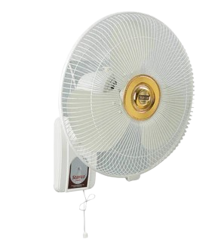

**Price: 7,750.00**

The Deluxe 18 Wall-Mounted Fan is a premium ventilation solution, designed to provide powerful airflow and sleek styling in a compact and space-saving design. With its robust 18-inch blades and advanced motor technology, this fan delivers a strong and quiet breeze, effectively cooling large areas and improving air circulation. Its adjustable speed settings, easy installation, and durable construction make it an ideal choice for homes, offices, and commercial spaces, providing a reliable and efficient cooling solution.

**Key features of deluxe 18” fans include:**

* **18-inch blade size** for powerful air circulation.
* **Adjustable tilt** for directing airflow in different directions.
* **Variable speed settings** (usually 3) for customized air control.
* **Oscillation function** for even distribution of air.
* **Durable and sturdy wall-mount design** for space-saving and stability.
* **Quiet operation** for minimal noise while in use.
* **Easy-to-use controls** for convenience.